2012 China (Zhengzhou) World Tourist Cities Expo
(2012.9.27-9.29)

Exhibition

Manual

Organizing Committee of the International Mayor's Forum on Tourism—Zhengzhou, China, 2012
- Expo Introduction
The International Mayor’s Forum on Tourism (IMFT), which is a biennial forum, will be held in Zhengzhou International Convention and Exhibition Centre (ZZICEC) on September 26-30, 2012. 2012 World Tourist Cities Expo-Zhengzhou(WTCE) China will be held during the forum, and it aims at expanding the opening-up of tourism industry, building a platform for the exchange and cooperation between international tourism and Henan, cultivating international brand of Exhibition, promoting the significant development of Henan province and China’s inbound tourism.
With a broad market and flourishing prospect of tourism, Henan province will provide the most ideal development platform for domestic and overseas travelling traders. We hope seeking common development with you and building a better tomorrow of Henan province’s tourism.
II．Main Events during Expo
1. 2012World Tourism Day celebrations ＆ Opening Ceremony of IMFT ＆ World Tourist Cities Happy Parade.
2. 2012 International Mayor’s Forum on Tourism-Zhengzhou, china
3. Evening dancing performance Fairy Tail of Luo River Goddess for WTCE.
4. Presentation of Briefing on Henan Province and Tourism Projects Talks.
5. 2012World Tourist Cities Expo-Zhengzhou, China.
Note：The schedule above is subject to change and will be announced in advance.
- Schedule
24th September (Monday) 08:30-17:30
Special Booths Set-up
25th September (Tuesday) 08:30-17:30
Special Booths Set-up /
Standard Booths Set-up /
Exhibitors’ registration
26th September (Wednesday) 08:30-21:30
Special Booths Set-up/
Standard Booths Set-up/
Exhibitors’ registration
27th September (Thursday) 08:30-17:30
Opening Ceremony/ Trader’s day
28th September (Friday) 08:30-17:30 Public visiting day
29th September (Saturday) 08:30-17:30 Public visiting day
17:30-24:00 Ending
Note：The schedule above is subject to change and will be announced in advance.
IV. Expo Location
No.2 Exhibition hall, Zhengzhou International Convention and Exhibition Center, Henan （No.1 Business Inner Ring Road, Zhengdong New District
V. Theme exhibitions and exhibitors of the Expo
(I) Theme Exhibitions

■Venue for Presentation of Henan Province and the tourism industry talks
■Venue for international tourism city
■Venue for domestic tourism city
■Venue for Henan Provincial cities, Travelling Counties directly governed by Henan Province, National Tourism Demonstration Counties
■Venue for tourism merchandise
■Venue for tourism, catering, hotels, travel agencies and other service enterprises

(II) Scope of Exhibits

■The participation of overseas tourist cities and tourist management organization.
■Tourist Administration of the domestic provinces, autonomous regions and municipalities.
■Tourist Administration of Hong Kong, Macao and Taiwan, and the Tourism Associations.
■Henan Provincial cities, Travelling Counties directly governed by Henan Province, National Tourism Demonstration Counties.
■Tourist Attractions: such as world Heritage Sites, Nature Reserves, theme parks, etc.
■Five-star hotels and tourism products.
■The enterprises which product and sell tourist merchandise, souvenirs, gifts, leisure products, native products, outdoor products.
■Food and Beverage Service Industry and enterprises which sell liquor and beverage.

VI. Expo Charges
Stand Category | Stand Size | Stand Fee | Stand Collocation
Standard Stand | 9㎡  (3m×3m) | inland：RMB3000 | 3 pieces of board;  Info Counter X 1;  folding chair X 2;  Waste Basket X 1；  FLUO Tube X 2；  lintel Board X 1；  wall-to-wall carpet X 1；  Socket X 1
Standard Stand | 9㎡  (3m×3m) | Overseas：USD500
(I):Standard Stand
Schematic Plan of Standard Stand 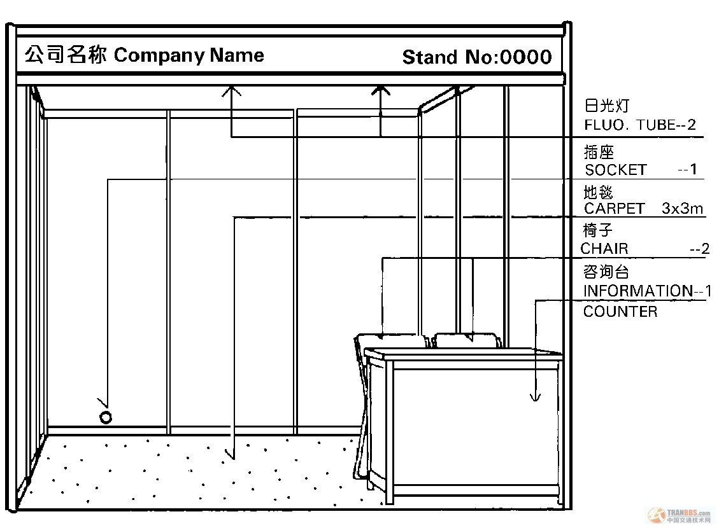
（II）Special Stand
Stand Category | Stand Size | Stand fee | NOTE:
Special stand | 36㎡above | inland：RMB300 per ㎡ | Management charge, electricity charge or other venue charges excluded
Special stand | 36㎡above | overseas：USD50 per ㎡
Ⅶ .The Expo Exhibition Notifications
(a) The Organizers and Managers

The Secretariat of The World Tourism City Expo organizing committee 2012 China (Zhengzhou) is responsible for the related organizations and daily management work of the Expo.

(b) The Qualification

Once receiving the application of participation unit and all of their expenses, the organizing committee office will issue a written notice to confirm the applicants’ participation qualifications, and will send out "stand confirmation", "stand distribution plan", " Participation manual” and other detailed information all together.
The application deadline: August 31, 2012.

(C) Stand Matters

1, Distribution: A high priority for stand area, the registration order is needed and, to meet the demand of exhibitor as far as possible.

2,Set-up: The set-up for special stand can be done by main construction company appointed by the exhibition organizers. If the exhibitors did not choose the main contractor, they must submit the building company‘s credential, stand designs, construction drawings, photocopy of special type of work, material description, the copy of responsibility for security guarantee, set-up of the engagement letter and related documents to the secretariat and need to pay the safety deposit (RMB300 per ㎡). The stand rental exhibitors, who want to modify the standard stand, must appoint the construction company specified by the organizing committee, and cost is paid by the exhibitors themselves.

3,Rent: The exhibitors shall not distribute, underlet or make assignments of their stand to other exhibitors without the prior written notice to the organizer; also they shall not use any other stands which are not allowed by the Organizer, or use it for other purpose than the exhibition.

(d) Site Management Regulations
To establish a good image and order of the exhibition, please cooperate by the following matters:
- During the exhibition, the host has the right to demand the exhibitors to take way any unsuitable display items.

- All exhibitors shall not take advantage of public space in order to keep clear.

- The exhibitors shall not make advertising and other propaganda activities at the outside of their stand.

4. Fake or inferior quality commodities, open flame and Electric heating device are prohibited inside the stand. Offenders will be not only confiscated deposit of exhibition and fined RMB5000, but also will be cancelled the Participation qualification.

5. Organizer will strengthen noise control to maintain exhibiting order. High-power audio equipment is strictly forbidden.

6. Organizer has the right to stop or terminate the active content in the stand which violates the exhibition purposes and related issues.

7. Organizer has the right to issue the supplementary provision and clause in order to ensure the exhibit proceeds smoothly. The provision will effect within 24 hours. Exhibitors must strictly comply with the related provisions.

(e) Security guard
There will be Security guard service during the stand installation and dismantling as well as exhibition. Exhibitors should agree the reasonable cause of the service and cooperate all safety management measures. Organizer has no liability for exhibitor’s lost of belongings and damage.

Others
- Secretariat reserves the right to cancel the qualification of those exhibitors who have the different identity between actual participation and sign-up and related expenses will be not refund.

- Secretariat has the right to cancel the qualification and terminate the activities for those exhibitors who violate the above provisions.

- Secretariat reserves the right to temporarily adjust the provisions and make the new supplement according to the arrangement.
VIII. Home service provider
Henan Xinglv Business Services CO. LTD
Contact person：Lu Jing 0371-65995328 13803715820
Li Hui 0371-65995308 13838071235
Liu Xiaoyan 0371-65995328 13598010754
Fax：0371-65995308 E-mail：hnxlsw@163.com

